**Laboratory 4 (3 days):**

**BJT characteristics, Small Signal Amplifiers**

**Material covered:**

* This laboratory has ***three sessions*** allocated for completion.

3rd session: Exercise 3 and Exercise 4

* BJT DC biasing, Forward active, reverse active, saturation
* Small signal models for BJTs
* Common emitter, common base, common collector configurations
* Small signal bandwidth

**Overview notes:**

*PSpice – Setting up DC Sweeps with a secondary sweep*

1. Select Simulation Profile and choose Primary Sweep
2. Indicate the source type, source name, start value, end value and increments. Make the increments sufficiently small that your plots look ‘smooth’
3. Select Secondary Sweep, checking the box on. Both Primary and Second Sweeps should have check marks in the associated boxes.
4. Again, indicate the source type, source name, start value, end value and increments.
5. After running the simulation, place an appropriate probe on the schematic and you will see plots of the probe type against the Primary Sweep variable. Each plot will correspond to a different Secondary Sweep step value.

***Note***: The DC biasing circuits for Exercises 4, 5 and 6 are the same. The resistors *R*1, *R*2, *R*C and *R*E comprise the DC bias resistors.

**Exercise 3: Common collector amplifier.**

1. Build the circuit shown in Figure 6 (below) using *V*CC = 4 V, *R*L = 100 kΩ, and *R*Sig = 100 Ω.

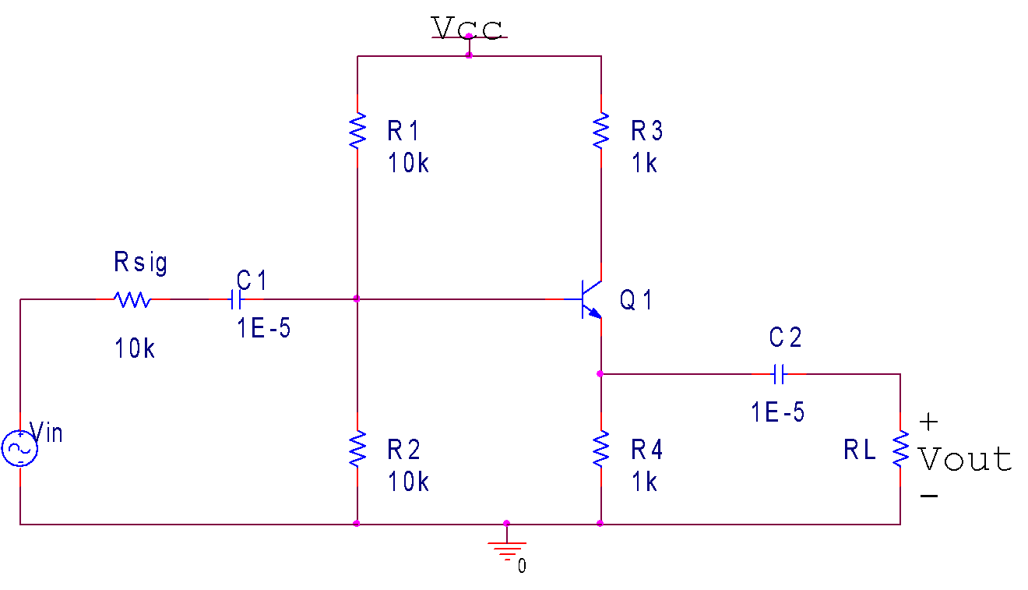

## Figure 6: BJT common-collector amplifier

*Analytically, using your measured* β *from Exercise 1 estimate the input resistance, R*In *, output resistance, R*Out *, and the open-circuit voltage gain, A*VOC*.*

From Exercise 1, our measured value was $β=203.351$

$$203.351=\frac{α}{1-α}$$

$$203.351-203.351α=α$$

$$α=\frac{203.351}{204.351}=0.9951$$

1. Set *R*Sig to 100 Ω and *R*L to 100 kΩ. Apply an input voltage with DC offset = 0 V, Vpk-pk = 0.2 V, frequency = 1 KHz.
2. Experimentally estimate the open-circuit voltage gain *A*VOC. Remember to set the V/Div such that the input profile of the measurement does not interfere with the circuit.

The Vin was measured AFTER $R_{sig}$, to match the following parts of the lab.

$$A_{VOC}=\frac{V_{out\left(p-p\right)}}{V_{in\left(p-p\right)}}=\frac{183.41mV}{193.30mV}=0.9488≈0.95$$

1. Change *R*Sig to 1 kΩ and *R*L to 1 kΩ.
2. Experimentally, determine the input resistance, *R*In . This can be done by measuring the current through *R*Sig and the voltage on the RHS of *R*Sig (= *v*in). Recall: *R*In = *v*in / *i*in

Measured $V_{Rsig}=V1-V2= 203.1mV - 113.96 mV=89.14 mV$

$$I_{in}=\frac{V_{Rsig}}{R_{sig}}=\frac{89.14*{10}^{-3}V}{1000 Ω}=89.14 μA$$

$$R_{in}=\frac{V_{in}}{I_{in}}=\frac{113.96*{10}^{-3}V}{89.14*{10}^{-6}A}=1278.43 Ω$$

1. Experimentally, determine the output resistance, *R*Out . This can be done by removing *R*L , applying a small AC voltage to the amplifier output, and measuring the current into the amplifier. Recall: *R*Out = *v*out / *i*out

We used a test resistor of 1k ohms to determine the current.

Measured $V_{Rtest}=V1-V2= 203.1mV - 78.557 mV=124.543 mV$

$$I_{out}=\frac{V_{Rtest}}{R_{test}}=\frac{124.543*{10}^{-3}V}{1000 Ω}=124.53 μA$$

$$R_{out}=\frac{V_{out}}{I_{out}}=\frac{78.557*{10}^{-3}V}{124.53*{10}^{-6}A}=630.828 Ω$$

1. For the same *R*Sig and *R*L , determine the overall voltage gain, *A*V .

*For all the above values, how do the experimental results compare to the analytic estimates?*

# Exercise 4: Common emitter amplifier

1. Build the circuit shown in Figure 7 (below) using *R*L = 100 kΩ with Vin set to zero. Set *V*CC to 4 V. Note: when you apply power, the current will increase slowly (why?). Wait until it reaches its final value before making measurements.

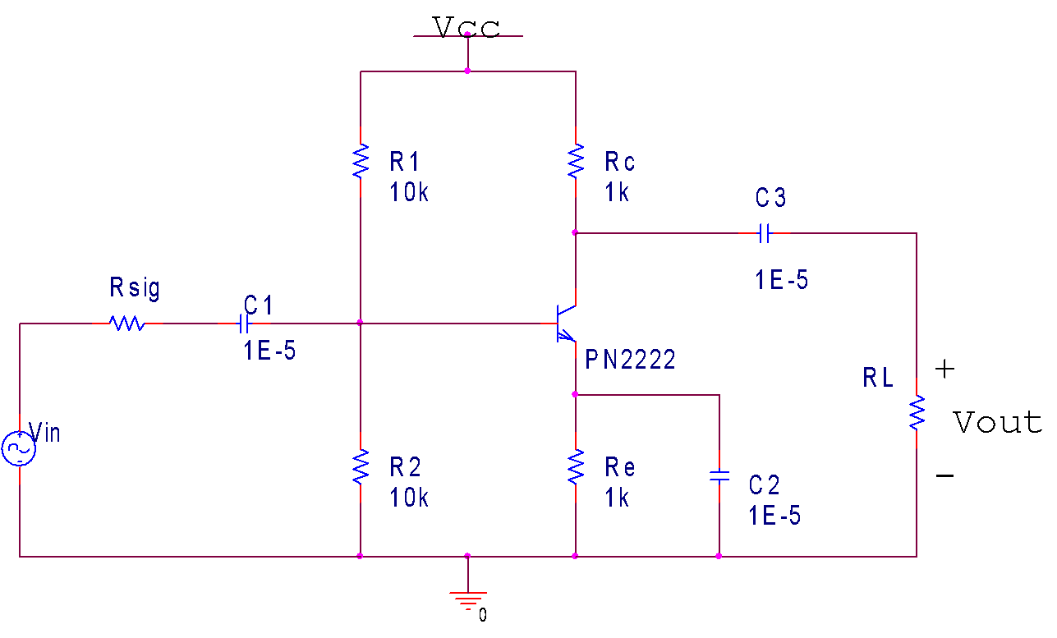

## Figure 7: BJT common-emitter amplifier

1. Verify that the DC bias characteristics are consistent with the previous exercise.

*Analytically, using your measured* β *from Exercise 3.1 estimate the input resistance, R*In *, output resistance, R*Out *, and the open-circuit gain, A*VOC *.*

1. Set *R*Sig to 100 Ω and *R*L to 100 kΩ. Apply an input voltage with DC offset = 0 V, Vpk-pk = 0.02 V, frequency = 1 kHz.
2. Experimentally estimate the open-circuit voltage gain *A*VOC. Remember to set the V/Div such that the input profile of the measurement does not interfere with the circuit.

1. Measure the current through *R*Sig. Use this measurement to experimentally estimate the input resistance, *R*In.

Measured $V_{Rsig}=V1-V2= 202.76 mV - 152.73 mV=50.03 mV$

$$I_{in}=\frac{V_{Rsig}}{R_{sig}}=\frac{50.03*{10}^{-3}V}{100 Ω}=500.3 μA$$

$$R_{in}=\frac{V_{in}}{I_{in}}=\frac{152.73*{10}^{-3}V}{500.3*{10}^{-6}A}=305.276 Ω$$

1. Replace *R*L with a 1 kΩ resistor and the output voltage. Use this measurement to estimate the output resistance, *R*Out.

Measured

1. For the same *R*Sig and *R*L, determine the overall voltage gain, *A*V.

*For all the above values, how do the experimental results compare to the analytic estimates?*

1. With *V*CC = 4 V, *R*Sig = 100 Ω, and *R*L = 1 kΩ, do a frequency sweep with VIn,pk-pk = 0.02 V and determine the 3 dB low and high frequency cutoffs.
2. Analytically, estimate the (low-frequency) cutoff frequency associated with each capacitor.

*How do your experimental values compare with an analytic estimate?*